System Design
- Reliability in System Design
Reliability in system design refers to the ability of a system to consistently deliver correct and expected performance over time, even under varying conditions or stress. It focuses on maintaining stable operation and reducing unexpected disruptions.
- System reliability refers to how consistently a system performs its intended functions without failure over a given period under specified operating conditions.
- It means the system can be trusted to work correctly, even under stress or in different conditions.
- A reliable system minimizes downtime, handles errors smoothly, and provides consistent performance to users.
Example: In an online banking system, reliability ensures that transactions are processed correctly every time without data loss or system crashes.
Factors That Affect Reliability
Several factors influence the reliability of a system. These factors determine how consistently a system can perform without failures.
- Design Quality: Poor system design or lack of proper planning can lead to frequent failures and unstable performance.
- Hardware Quality: Low-quality components or hardware wear and tear can cause system breakdowns.
- Software Bugs: Errors in the code can lead to crashes, incorrect outputs, or unexpected behavior.
- Maintenance: Lack of regular updates, monitoring, and testing can reduce system reliability.
- Workload: Overloading the system beyond its capacity can slow it down or cause failures.
- External Conditions: Environmental factors like heat, power failures, or network issues can affect performance.
- Redundancy: Without backup systems or failover mechanisms, the system becomes more prone to downtime.
Ways to Improve System Reliability
These approaches help systems remain stable, reduce failures, and maintain consistent performance under different conditions.

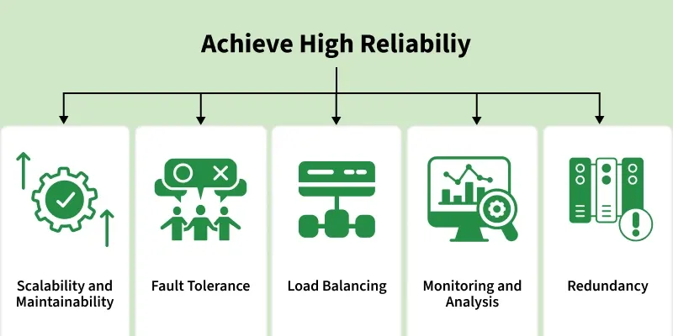
- Scalability and Maintainability: It ensure the system continues to work efficiently as it grows and evolves over time.
- Fault Tolerance: It enables the system to detect errors and recover automatically without failure.
- Load Balancing: It is used to distributes traffic across systems to avoid overload and handle high demand smoothly.
- Monitoring and Analytics: Monitoring and analytics track performance and help detect issues early.
- Redundancy: Remove duplicates critical components so the system keeps running even if one fails.
Differences between Reliability and Availability
Some of the differences between reliability and availability are:
Reliability | Availability
Reliability is the ability of a system to perform its intended functions correctly for a specific period of time without failure. | Availability is the percentage of time a system remains operational and accessible to users.
It focuses on failure-free operation over a period of time. | It focuses on whether the system is working at a specific moment.
Measured using metrics like Mean Time Between Failures (MTBF) and Mean Time To Repair (MTTR). | Measured as uptime percentage, such as 99%, 99.9%, or 99.99%.
It is considered a long-term measure of system performance and stability. | It is often considered a short-term measure of system accessibility.
A reliable system fails less frequently. | A highly available system recovers quickly from failures.
Focuses on reducing system failures through good design and quality components. | Focuses on minimizing downtime using redundancy and failover mechanisms.
Example: A database that rarely crashes over months is considered reliable. | Example: A website that quickly recovers after a server crash is considered highly available.
Ways to Measure Reliability
Here’s how reliability can be measured with formulas for better clarity:
1. Uptime Percentage
This metric measures the percentage of time a system remains operational during a specific period.
Uptime Percentage = ((TotalTime-Downtime) / TotalTime ) * 100
Example: If a system was down for 2 hours in a week (168 hours), uptime will be:
Uptime = ((168-2)/168) * 100 = 98.81%
2. Mean Time Between Failures (MTBF)
MTBF indicates the average time a system operates before experiencing a failure.
MTBF = (Total Operational Time / Number of Failures)
Example: If a system runs for 1000 hours and fails 5 times, MTBF will be:
MTBF = (1000/5) = 200 hours
3. Mean Time to Repair (MTTR)
MTTR measures the average time required to repair a system and restore it to normal operation after a failure.
MTTR = Total Repair Time / Number of Failures
​Example: If the system took 10 hours to repair 5 failures, MTTR will be:
MTTR = 10/5 = 2 hours
4. Error Rate
Error rate shows the percentage of operations or transactions that result in errors.
Error Rate = (Number of Errors / Total Transactions or Operations) * 100
Example: If there are 50 errors in 10,000 operations , Error rate will be:
Error Rate = (50/10000) × 100 = 0.5%.
These formulas help quantify reliability, making it easier to identify weak points and areas for improvement.
Reasons for System Failures
Systems can become unreliable when they experience frequent failures, poor performance, or unexpected disruptions. These issues often arise due to design flaws, resource limitations, or external factors affecting system stability.
- Poor System Design: Inadequate architecture or lack of proper planning can lead to unstable systems and frequent failures.
- Hardware Failures: Physical components such as servers, disks, or network devices may fail over time due to wear and tear.
- Software Bugs: Errors in the application code or configuration can cause crashes, incorrect outputs, or unexpected behavior.
- Overloaded Systems: When systems handle more traffic or workload than they are designed for, performance may degrade or services may fail.
- Network Issues: Slow or unstable network connections can interrupt communication between system components.
- Lack of Monitoring and Maintenance: Without proper monitoring, updates, and regular maintenance, small issues can grow into major system failures.
- Single Point of Failure (SPOF): If a critical component fails and no backup is available, the entire system may stop functioning.
Single Point of Failure (SPOF)
A Single Point of Failure (SPOF) is a component in a system whose failure can cause the entire system to stop working. Systems that require high availability must avoid SPOFs to maintain reliability and continuous operation.
- A single failure in a critical component can disrupt the entire system.
- SPOFs reduce system reliability and increase the risk of downtime.
- Eliminating SPOFs improves system resilience and stability.
- Redundancy is commonly used to prevent failures from affecting the entire system.
Ways to Avoid Single Point of Failure (SPOF)
Avoiding single points of failure is important for building reliable and resilient systems. The following strategies can help eliminate SPOFs:
- Redundancy: Duplicate critical components so that backup systems can take over if one component fails.
- Load Balancing: Distribute workloads across multiple servers to prevent overloading a single component.
- Failover Mechanisms: Automatically switch to backup systems when the primary system fails.
- Regular Testing: Conduct stress testing and failure simulations to detect weaknesses early.
- Monitoring and Alerts: Continuously monitor system health and receive alerts when issues occur.
- Proper Documentation: Maintain clear documentation to help engineers quickly troubleshoot and resolve problems.
- Continuous Improvement: Regularly update and improve system architecture using best practices.
- Scalability in System Design
Scalability refers to a system’s ability to handle increasing workloads, users, or data without affecting performance.. A scalable system can expand resources such as servers, storage, or processing power when needed.
- When a system's workload or scope rises, it should be able to maintain or even improve its performance, efficiency, and dependability. This is known as scalability.
- A system must be scalable in order to accommodate growing user traffic, data volumes, or computing demands without suffering a major performance hit or necessitating a total redesign.
Example: A video streaming platform that automatically adds more servers when millions of users start watching content at the same time.
Real-World Examples of Scalable Systems
There are many real-world examples of scalable systems that demonstrate the importance and impact of scalability in modern technology.
- Google: Uses a highly scalable distributed system (Bigtable, MapReduce, Spanner) to handle billions of searches globally.
- AWS: Offers scalable cloud services that let businesses easily scale compute, storage, and databases on demand.
- Netflix: Relies on cloud infrastructure, microservices, and caching to stream content to millions of users at once.
These examples highlight how scalability helps companies deliver reliable performance, handle traffic spikes, and grow rapidly without infrastructure limitations.
Ways to Achieve Scalability
These are common approaches used to handle increasing load and improve system performance efficiently.
1. Make It Bigger
Vertical Scaling, Like upgrading a car with a bigger engine for more power.
- Upgrading a system by adding more CPU, memory, or storage to a single server, similar to increasing a car’s engine power.
- Suitable for small applications and quick scaling, but limited by hardware constraints and cannot scale indefinitely.
2. Get More Cars
Horizontal Scaling, Like using multiple cars to share the workload.
- Scaling by adding multiple servers or instances to share the workload, similar to using multiple cars instead of one.
- Distributes traffic across resources efficiently, making it ideal for large-scale applications with high user demand.
3. Divide and Conquer
Microservices, Treats the app as small, independent services.
- Breaks the application into small, independent services that handle specific functionalities.
- Allows scaling of only required parts, improving flexibility and efficient resource utilization.
4. No Servers, No Problems
Serverless, Removes the need to manage servers.
- Automatically scales based on demand without requiring manual server management.
- Cost-efficient for variable workloads, with services like AWS Lambda handling execution and scaling.
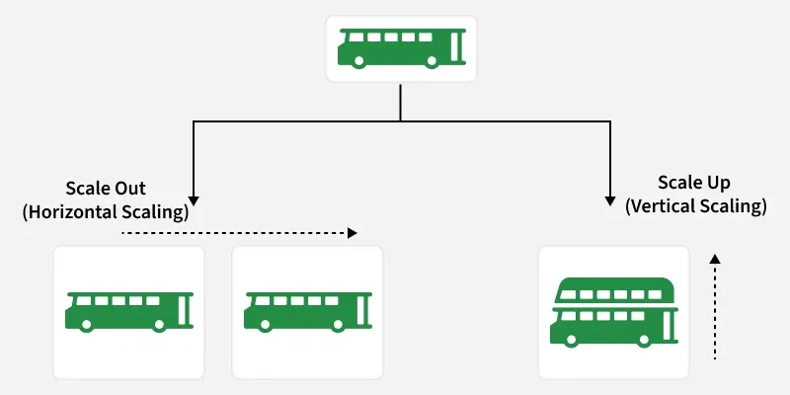
Factors Affecting Scalability
The factors that affects the scalability with their explanation are:
1. Performance Bottlenecks
Performance bottlenecks are components or processes in a system that limit overall performance and slow down operations.
- Performance bottlenecks are parts of a system that slow down overall performance.
- They are often caused by slow databases, inefficient code, or limited resources.
2. Resource Utilization
Efficient use of system resources is important to maintain performance and support system scalability.
- Efficiently using resources such as CPU, memory, and disk space is essential for scalability.
- Inefficient resource utilization can lead to bottlenecks and limit the system's ability to scale.
3. Network Latency
Network latency refers to the delay that occurs when data travels between systems or network nodes.
- Network latency is the delay in data transmission.
- High latency slows node communication and affects scalability.
4. Data Storage and Access
The way data is stored and accessed plays a major role in determining how well a system can scale.
- Data storage and access patterns affect scalability.
- Distributed databases and caching help systems scale better.
5. Concurrency and Parallelism
Concurrency and parallelism allow systems to process multiple tasks at the same time to improve performance.
- Enables handling of multiple tasks simultaneously, improving scalability and system efficiency.
- Increases throughput by processing more requests, but may introduce latency due to synchronization and overhead if not managed properly.
6. System Architecture
System architecture determines how components are structured and how easily the system can scale.
- System architecture defines how easily a system can scale, with modular and loosely coupled components improving flexibility.
- Supports both horizontal scaling (adding instances) and vertical scaling (upgrading resources) for better performance.
Components that help to increase Scalability
Some of the main components that help to increase the scalability are:
- Load Balancer: A load balancer distributes incoming traffic across multiple servers to avoid overload and improve performance and availability.
- Caching: Caching stores frequently accessed data temporarily to reduce latency and backend load.
- Database Replication: Database replication creates multiple copies of data (often asynchronously) to improve availability and read performance, with trade-offs in consistency.
- Database Sharding: Database sharding splits data into smaller shards to scale databases across multiple instances.
- Microservices Architecture: Microservices architecture divides applications into independent services that can scale separately.
- Data Partitioning: Data partitioning divides data based on criteria like user or region to improve scalability.
- Content Delivery Networks (CDNs): CDNs deliver cached content from locations closer to users, reducing latency.
- Queueing Systems: Queueing systems handle requests asynchronously to manage traffic spikes and prevent overload.
Challenges and Trade-offs in Scalability
Challenges and trade-offs include:
- Cost Vs Scalability: Scaling improves performance and availability but often increases infrastructure and operational costs.
- Complexity: As systems scale, they become harder to manage, maintain, and debug, raising operational overhead.
- Latency Vs Throughput: There is often a trade-off between latency and throughput. Optimizing for low latency may reduce throughput, and vice versa.
- Data Partitioning Trade-offs: Partitioning boosts scalability but requires careful balance of partition size, data movement, and data locality.
- Maintainability in System Design
Maintainability refers to how easily a software system can be modified, updated, or improved over time. It ensures developers can fix issues, add features, and enhance components with minimal disruption to the system.
- The system is structured into smaller modules so individual parts can be changed without affecting the entire application.
- Clear, readable code along with version control and automated testing helps track changes and quickly detect issues.
Example: In a large web application, developers organize the system into separate modules such as authentication, payment, and user management. This allows teams to update one module without impacting the rest of the application.
Measuring Maintainability
While measuring maintainability is subjective, here are some metrics to measure it:
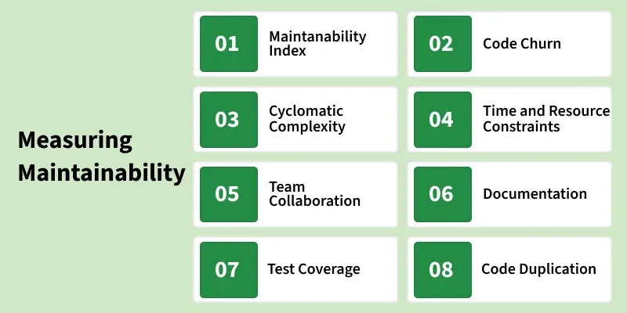
1. Maintainability Index
It gives a score to measure how maintainable a code module or system is. It considers factors like complexity and duplication, and may vary by IDE. A higher score means better maintainability and easier code improvements.
2. Code Churn
It tracks how often a code module is modified over time using version control data. High churn can indicate instability, while monitoring it helps identify areas needing extra testing and attention.
3. Cyclomatic Complexity
It measures the complexity of a code module. Higher complexity is an indication that the code is more complicated to understand and there may be potential easier ways available to break the complexity of a particular code module.
4. Time and Resource constraints
It's important to balance between speed of development as well as speed of maintainability. A rush by the development team to complete a tight deadline without considering maintainability can lead to complicated future maintenance efforts.
5. Team Collaboration
A strong collaborative culture within the development team helps them share knowledge with each other, perform Knowledge Transfer programs (KT), mentor newcomers, and work together on maintenance tasks, it helps team members grow together and makes sure someone won't struggle in doing a particular task.
6. Documentation
A Good documentation is the one, which makes a newcomer understand the project and also covers not only code comments but also architectural decisions, System design, API references, as well.
7. Test Coverage
It measures the extent to which automated tests cover the codebase, It helps prevent regressions from being introduced. Test coverage tools assess the extent of code exercised by automated tests, expressed as a percentage.
8. Code Duplication
It measures how much repeated code exists in a system. High duplication increases maintenance effort because changes must be updated in multiple places. It is detected using static analysis tools that find similar code segments.
Hidden Costs of Poor Maintainability
Poor maintainability makes systems harder to understand and modify, reducing efficiency and stability. It increases development time and complexity, slowing down the delivery of new features.
- Increase in Technical Debt: Quick fixes and temporary solutions accumulate over time, making the codebase more complex and harder to manage.
- Slower Bug Fixing: Developers may spend significant time understanding complicated code before resolving issues.
- Difficult Test Maintenance: Automated tests may frequently break when the underlying code is poorly structured or tightly coupled.
- Delayed Development Cycles: Poor maintainability can slow down feature development and make meeting project deadlines challenging.
- Unreliable Testing: Poorly organized code makes it difficult to create stable and effective test cases.
Ways to achieve high Maintainability
Designing a highly maintainable system requires a proactive approach during the development process. Here are some strategies to achieve and improve maintainability in system design:
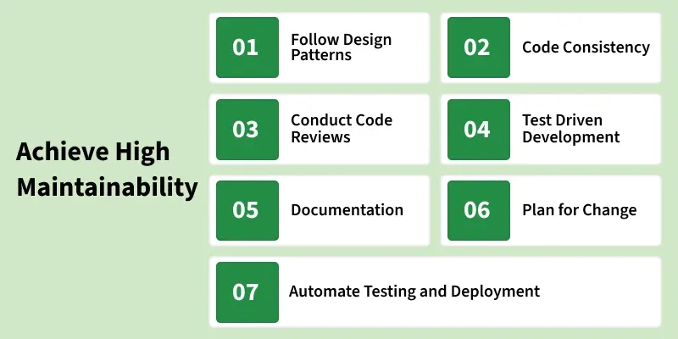
1. Follow Design Patterns
Design patterns, such as Model-View-Controller and SOLID principles, promote modularity, and flexibility. Following these patterns enhances overall architecture while making it easier to maintain.
2. Code Consistency
Well-written, readable code with meaningful variables, comments, and documentation makes maintenance tasks even smoother. So, as much as possible while writing code or documentation make it simple in design and implementation.
3. Conduct Code Reviews
Code reviews by peers and maintainers help identify potential issues early while ensuring that code adheres to maintainability standards and coding style guidelines.
4. Test-Driven Development (TDD)
Adopting TDD ensures that test cases are written before the code implementation, helping developers understand the codebase easily while troubleshooting an issue.
5. Documentation
Good documentation reduces the learning curve for new Devs and helps the existing team understand it better during maintenance. Maintain thorough documentation of the system's architecture, APIs, modules, and dependencies.
6. Plan for Change
Design the system in such a way, that makes it easier to add new features and adapt to evolving requirements of daily enhancements.
7. Automate Testing and Deployment
Automating testing and deployment reduces the chance of human error and helps maintain system stability during updates, while also saving time and effort for the team.
Challenges in Maintainability
Maintaining a large software system can become difficult as the system grows in size and complexity. Various technical and organizational factors can reduce maintainability and make updates or bug fixes more time-consuming.
• Complex Code Structure: Highly complex or tightly coupled code makes it difficult for developers to understand and modify the system.
• Poor Documentation: Lack of proper documentation makes it harder for new developers to understand system architecture and functionality.
• Frequent Requirement Changes: Continuous changes in requirements can make the system harder to maintain if the design is not flexible.
• Code Duplication: Repeated code across different modules increases maintenance effort because changes must be applied in multiple places.
• Lack of Automated Testing: Without proper testing, even small changes may introduce new bugs, making maintenance risky.
• Technical Debt: Quick fixes or temporary solutions added over time can make the system harder to manage and update.
System Design Life Cycle (SDLC)
The System Design Life Cycle (SDLC) is a structured process used to plan, design, develop, test, deploy, and maintain software systems. It helps teams build reliable, scalable, and high-quality systems by following well-defined phases, ensuring that business requirements are correctly translated into technical solutions.
- Provides a clear roadmap from idea to deployment.
- Improves project planning, tracking, and control.
- Ensures better quality through systematic testing.
- Reduces development risks and cost overruns.
- Enhances collaboration between stakeholders and developers.
- Makes systems easier to maintain and scale over time.
Below is the objective and example of each stage of System Design Life Cycle:
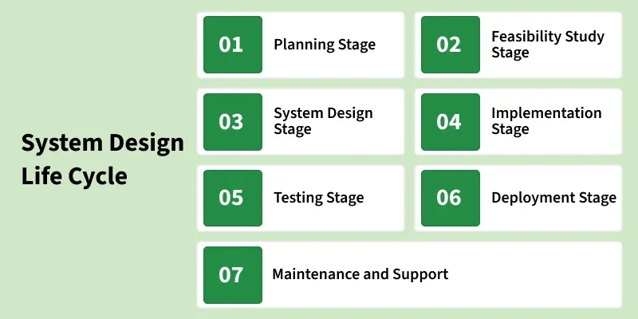
[Stage 1]: Planning
- This is where the project starts! You decide what you want to achieve (goals), how much you can spend (budget), and who will work on it (team).
Example: A company plans to build a customer management system and outlines its key features and the team involved.
[Stage 2]: Feasibility Study
- Before starting, check if the idea is practical. Will it work technically? Is it affordable?
Example: The company checks if building the system is worth the cost and effort and whether it can deliver the expected benefits.
[Stage 3]: System Design
- This stage is all about planning how the system will work behind the scenes and how it will look to users.
- Imagine designing a house, before construction begins, architects create blueprints that show where every room, pipe, and wire will go. Similarly, in system design, you create a detailed plan that developers will follow to build the system.
[Stage 4]: Implementation
- Transform the design into an operational system. Developers write the code to create the system based on the design.
Example: The CRM system's features, like customer profiles and dashboards, are coded
[Stage 5]: Testing
- Verify that the system meets the specified requirements and makes sure everything works as planned.
- The CRM system undergoes various testing procedures, such as unit testing, integration testing, and user acceptance testing, to ensure its functionality, performance, and security.
[Stage 6]: Deployment
- All the hard work concludes at the deployment phase, when the system is made accessible for real usage. After all the planning, designing, and building is finished, it's similar like launching a new store.
- This stage involves transferring the system from a testing or development environment to a production environment where actual users can access it.
[Stage 7]: Maintenance and Support
- Ensure the ongoing functionality and address any issues that arise.
- Regular updates, bug fixes, and user support for the CRM system to adapt to changing business requirements and address any emerging issues.
Differences between the System Development Life Cycle and the System Design Life Cycle
Below are the differences between System Development Life Cycle and System Design Life Cycle:
Aspect | System Development Life Cycle | System Design Life Cycle
Definition | A comprehensive framework covering the entire system development process. | A subset of the SDLC that specifically deals with designing the system.
Scope | Encompasses the entire life cycle of a system, form initiation to retirement. | Focuses primarily on the design aspects of the system.
Phases | Typically includes Planning, Analysis, Design, Implementation, Testing, Deployment, and Maintenance. | Usually includes Feasibility Study, System Analysis, System Design, Implementation, Testing, Deployment, and Maintenance.
Focus | Broad focus on the overall development process, addressing planning, implementation, testing, and maintenance. | Specific focuses on the design phase, detailing how the system will be built and operate.
Purpose | Guides the development team through the entire process, from concept to post-deployment support. | Provides a blueprint for constructing the system based on specified design requirements.
Challenges in System Design Life Cycle
Below are the challenges in System Design Life Cycle:
- Sometime, the initial requirements for a system might be unclear or ambiguous, leading to difficulties in designing the system accurately.
- Requirements may change during the design process, posing a challenge to maintain consistency and ensuring that the system still meets the user's needs.
- Rapid advancements in technology can make it challenging to choose the most suitable and up-to-date technologies for system design.
- Ensuring seamless integration of various system components can be complex, especially when dealing with different technologies and platforms.
- Designing a system within budgetary constraints can be challenging, as incorporating certain features or technologies might be cost-productive.
Models Used for System Design Life Cycle
Below are the models used for System Design Life Cycle:
- Waterfall Model: A linear and sequential model where each phase must be completed before moving on to the next. It's a straightforward approach but can be inflexible in the face of changing requirements.
- Iterative Model: Involves repeating cycles, with each iteration refining and improving the system based on feedback. It's adaptable to changing requirements.
- Prototyping Model: Involves building a prototype (a preliminary version) of the system to gather feedback refine the design before building the final product.
- Spiral Model: Incorporates elements of both iterative and prototyping models. It involves cycles of planning, designing, constructing, and evaluating.
- Agile Model: Emphasizes flexibility and collaboration, with frequent iterations and continuous feedback. It's well suited for projects where requirements may evolve.
Iterative nature of SDLC
The iterative nature of the System Design Life Cycle (SDLC) means the process is not strictly linear; instead, it involves revisiting and refining stages based on feedback and evolving requirements. This ensures the system remains adaptable and aligned with its objectives.
Key Aspects of Iteration in SDLC:
- Refining Requirements: Stakeholders may identify additional needs or changes after deployment or testing. These insights prompt revisiting earlier phases, such as planning or design, to incorporate updates.
- Prototyping and Testing: Prototypes or early iterations of the system are developed and evaluated. Better performance and user satisfaction are ensured by improving the design and implementation based on feedback from these trials.
- Adapting to Changes: The system design is reviewed and modified to be relevant and efficient as user expectations, technological advancements, or corporate objectives change.
The system may gradually evolve to satisfy present and future expectations due to this iterative process, which also ensures ongoing improvement and reduces risks. It's similar to building a bridge and then modifying it over time to handle growing traffic or changing conditions.
Best Practices in System Design Life Cycle
Below are the best practices in System Design Life Cycle:
- Invest time in thoroughly understanding and documenting requirements to provide a solid foundation for the design process.
- Maintain open communication with stakeholders to ensure their needs are understood and to address any changes promptly.
- Design systems in a modular fashion, allowing for easier maintenance, updates, and scalability.
- Identify potential risks early in the design process and develop strategies to mitigate or manage them effectively.
Use Cases of System Design Life Cycle
The SDLC is used in a wide variety of projects, from developing small applications to building large enterprise systems. Some common use cases for the SDLC includes:
- Developing new software applications.
- Enhancing existing software applications.
- Integrating different systems together.
- Replacing legacy systems.
- Developing custom solutions for specific business needs.
By following the best practices and using the appropriate SDLC model, organizations can increase their chances of successfully completing their system development projects.

